Instructions for Participant Initiated Non-RID Activities

Instructions for Participants

Step One:

Choose the activity/conference you want to attend. The activity/conference does not have to pertain strictly to interpreting. It can be a regional or national conference of another profession or could be a formal in-service training by an employer. As long as the activity is educationally beneficial to you as an interpreter, it can earn CEUs for you!

Step Two:

Contact an RID Approved Sponsor and secure their agreement to process the paperwork for the conference. Be sure to discuss the Content Area for which you are applying (Professional Studies or General Studies).

How many CEUs will be earned? (1 CEU = 10 contact hours)

Step Three:

Complete the Participant Initiated Activity Plan and Activity Report form from your RID Sponsor.

Attach pertinent documentation such as an agenda, program book.

Return form and documentation to your Sponsor who will keep the form until your activity is completed.

This form must be sent to your Sponsor before the activity begins

Step Four:

Upon completion of the activity, attain a certificate of attendance or documentation such as an agenda or program book.

Send documentation to your Sponsor.

*The participant must provide copies of registration, conference agenda, or other documentation that identifies content, hours, and attendance to enable the Sponsor to determine the appropriate number of CEUs and Content Area(s).

.

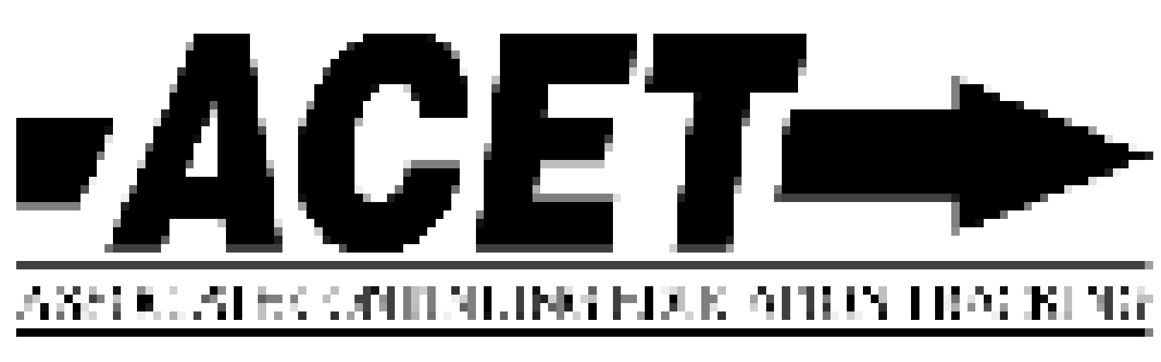
Participant Initiated Non-RID Activities 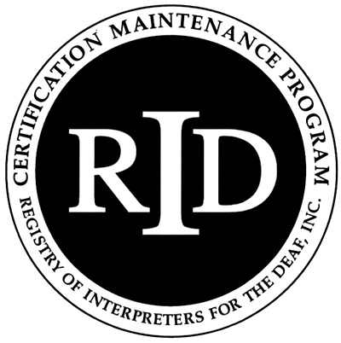
(PINRA)

This form will be used if an RID member plans to attend another organization’s workshop, conference, formal in-service training or activity. The RID Approved Sponsor will determine if the activity is appropriate for CEUs.

Before the start of the activity/conference, this section must be filled out
and signed by both the participant and RID Approved Sponsor:

Participant Name: RID Member #:

Participant Address:

Email: Phone #:

Activity/Conference Name:

Activity/Conference Theme or Focus (attach brochure/flier)

Date and Times of activities you will attend:

Total number of CEUs to be awarded:

Circle content area: Professional Studies General Studies

I certify that this activity/conference represents a valid and verifiable Continuing Education Experience that exceeds
routine employment responsibilities.

Participant Signature: . Date:
===========================================================================
Name and Code of RID Approved Sponsor: . .Kentucky Registry of Interpreters for the Deaf

I certify that I received this activity plan prior to the start of the activity/conference and I agree to sponsor this Continuing Education Experience. I will verify successful completion prior to awarding CEUs.

RID Sponsor Administrator Name: Signature: ______________________

RID Sponsor Code: Date: Click here to enter a date.

This section must be filled out and signed upon completion of the activity/conference:

Activity Code Number Click here to enter text. CEUs Awarded: Click here to enter text.

I have verified that the participant attended this activity/conference and that the activities listed are appropriate educational experiences which should be awarded the number of CEUs denoted above.

RID Approved Sponsor Signature Administrator: Click here to enter text.Date: Click here to enter a date.

The Participant must send documentation of attendance to the Sponsor upon completion of the activity. The Sponsor must file this form with RID online at myaccount.rid.org within 45 days of the completion of the activity/conference.

