**Continuing Education Activity Plan**

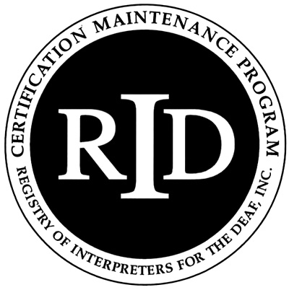

**Instructor’s Form**

This form is to be completed by either the instructor or RID Sponsor and kept on file with the Sponsor form.

The RID Sponsor will submit the completed Activity Plan online by logging in to their account at myaccount.rid.org prior to the start of the activity.

**RID Sponsor Name:** **Kentucky Registry of the Deaf**

**Presenter/instructor name(s)** (Please attach bio/resume):

**Date(s)/time of activity:**

**Title of activity:**

**Level of participant’s prior knowledge of topic:**

☐ Little/None

☐ Some

☐ Extensive

☐ Teaching

**Target audience:**

**Is this activity closed to the public and should not be listed in the searchable RID database?**

☐ Yes ☐ No

**Subject Code** (Select all that apply):

☐ Medical

☐ Legal

☐ Deafblind

☐ Deaf Culture

☐ Team Interpreting

☐ Deaf

☐ Ergonomics

☐ Mental Health

☐ Education (K-12)

☐ Education (Post-secondary)

☐ Oral

☐ Tri-lingual

☐ Mentoring/teaching

☐ Religious

☐ Visual/auditory

☐ Video

☐ Drugs/alcohol

☐ Performing Arts

☐ ASL/linguistics

☐ Sign to Voice

☐ Ethical

☐ Memory building

☐ Repetitive motion injury

**Media/Materials** (List the equipment and materials you will use and who is responsible for providing them):

**Workshop/course description:**

**Observable and measurable educational objectives** (List specific measurable actions by participants that will demonstrate comprehension and integration of information presented. For example, *Upon completion, participants will be able to: Determine and apply “minimum amount necessary rule” to their work, identify actual and/or potential FERPA & HIPAA violations in their work, integrate strategies to safe guard against violations into their work.* Refer to the list of verbs for formulating educational objectives):

Upon completion of this workshop, participants will be able to:



**Evaluation & Assessments** (Describe how you will evaluate student learning & presentation effectiveness. For example, *Presenter will check for understanding periodically and invite questions throughout and at the conclusion of the workshop. Additionally, participants will apply concepts to scenarios and complete a program evaluation.*):



**List of Verbs for Formulating Educational Objectives**

*The following verbs have been found to be effective in formulating educational objectives.*

**Those that communicate knowledge**

***Information:***

cite

identify quote

relate tabulate count indicate

read

repeat

tell

define

list

recite

select

trace

describe name recognize state

update

draw

point

record summarize write

***Comprehension:***

assess

contrast

distinguish

interpolate

restate

associate

demonstrate

estimate

interpret

review

classify

describe

estimate

interpret

review

translate

compare

differentiate

express

predict

compute

discuss

extrapolate

report

***Application:***

apply

employ

match

relate

sketch

calculate

examine

operate

report

solve

choose

illustrate

order

restate

translate

complete

interpolate

practice

review

treat

demonstrate

interpret

predict

schedule

use

develop

locate

prescribe

select

utilize

***Analysis:***

analyze

criticize

diagram

infer

question

appraise

debate

differentiate

inspect

separate

contract

deduce

distinguish

inventory

separate

contrast

detect

experiment

measure

***Synthesis:***

arrange

construct

formulate

organize

produce

assemble

create

generalize

plan

propose

collect

design

integrate

prepare

specify

combine

detect

manage

prescribe

validate

compose

document

***Evaluation:***

appraise

critique

evaluate

rank

score

assess

decide

grade

rate

select

choose

determine

judge

recommend

test

compare

estimate

measure

revise

**Those that impart skills**

demonstrate

hold

massage

pass

visualize

diagnose

integrate

measure

write

diagram

internalize

operate

project

empathize

palpate

record

listen

**Those that convey attitudes**

acquire

exemplify

plan

reflect

transfer

consider

modify

realize

revise

**Those that should be avoided**

Appreciate

have faith in

know

learn

understand

believe