**Continuing Education Activity Plan**

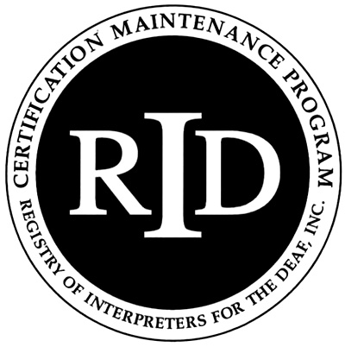

**Sponsor Form**

It is recommended, but not required, that this activity be submitted ONLINE at myaccount.rid.org at least 30 days prior to the start of the activity. A copy of this form along with the Activity Plan Instructor’s form must be kept on file for future auditing purposes.

Name of Approved Sponsor: **Kentucky Registry of Interpreters for the Deaf**

Activity Number: **0048**. .

(Sponsor Code) . (MonthYear) . (Ascending within month)

Activity Title: Click here to enter text.

Location of Activity: Click here to enter text.(City) Click here to enter text. (State)

Instructor(s) Name(s): Click here to enter text.

Contact Person/People: Click here to enter text. Contact Phone(s):Click here to enter text.

E-mail Click here to enter text. Web site: Click here to enter text.

Who is the Target Audience: Click here to enter text.

Activity Start Date: Click here to enter a date. Activity Completion Date: Click here to enter a date.

Start Time for Activity: Click here to enter text. Ending Time for Activity: Click here to enter text.

Total number of CEUs to be awarded to each participant: Click here to enter text. =========================================================================== **Content Area: Content Level: Participating Programs:**

☐Professional Studies (PS) ☐Little/none ☐CMP only

☐General Studies (GS) ☐Some ☐ACET only

☐Extensive ☐CMP & ACET Both

☐Teaching

As the RID Approved Sponsor for the RID activity, I certify that the above information is accurate and will be filed ONLINE with RID through [myaccount.rid.org](http://www.rid.org) prior to the start of the activity.

RID Approved Sponsor Signature Administrator: Click here to enter text. Date: Click here to enter a date.